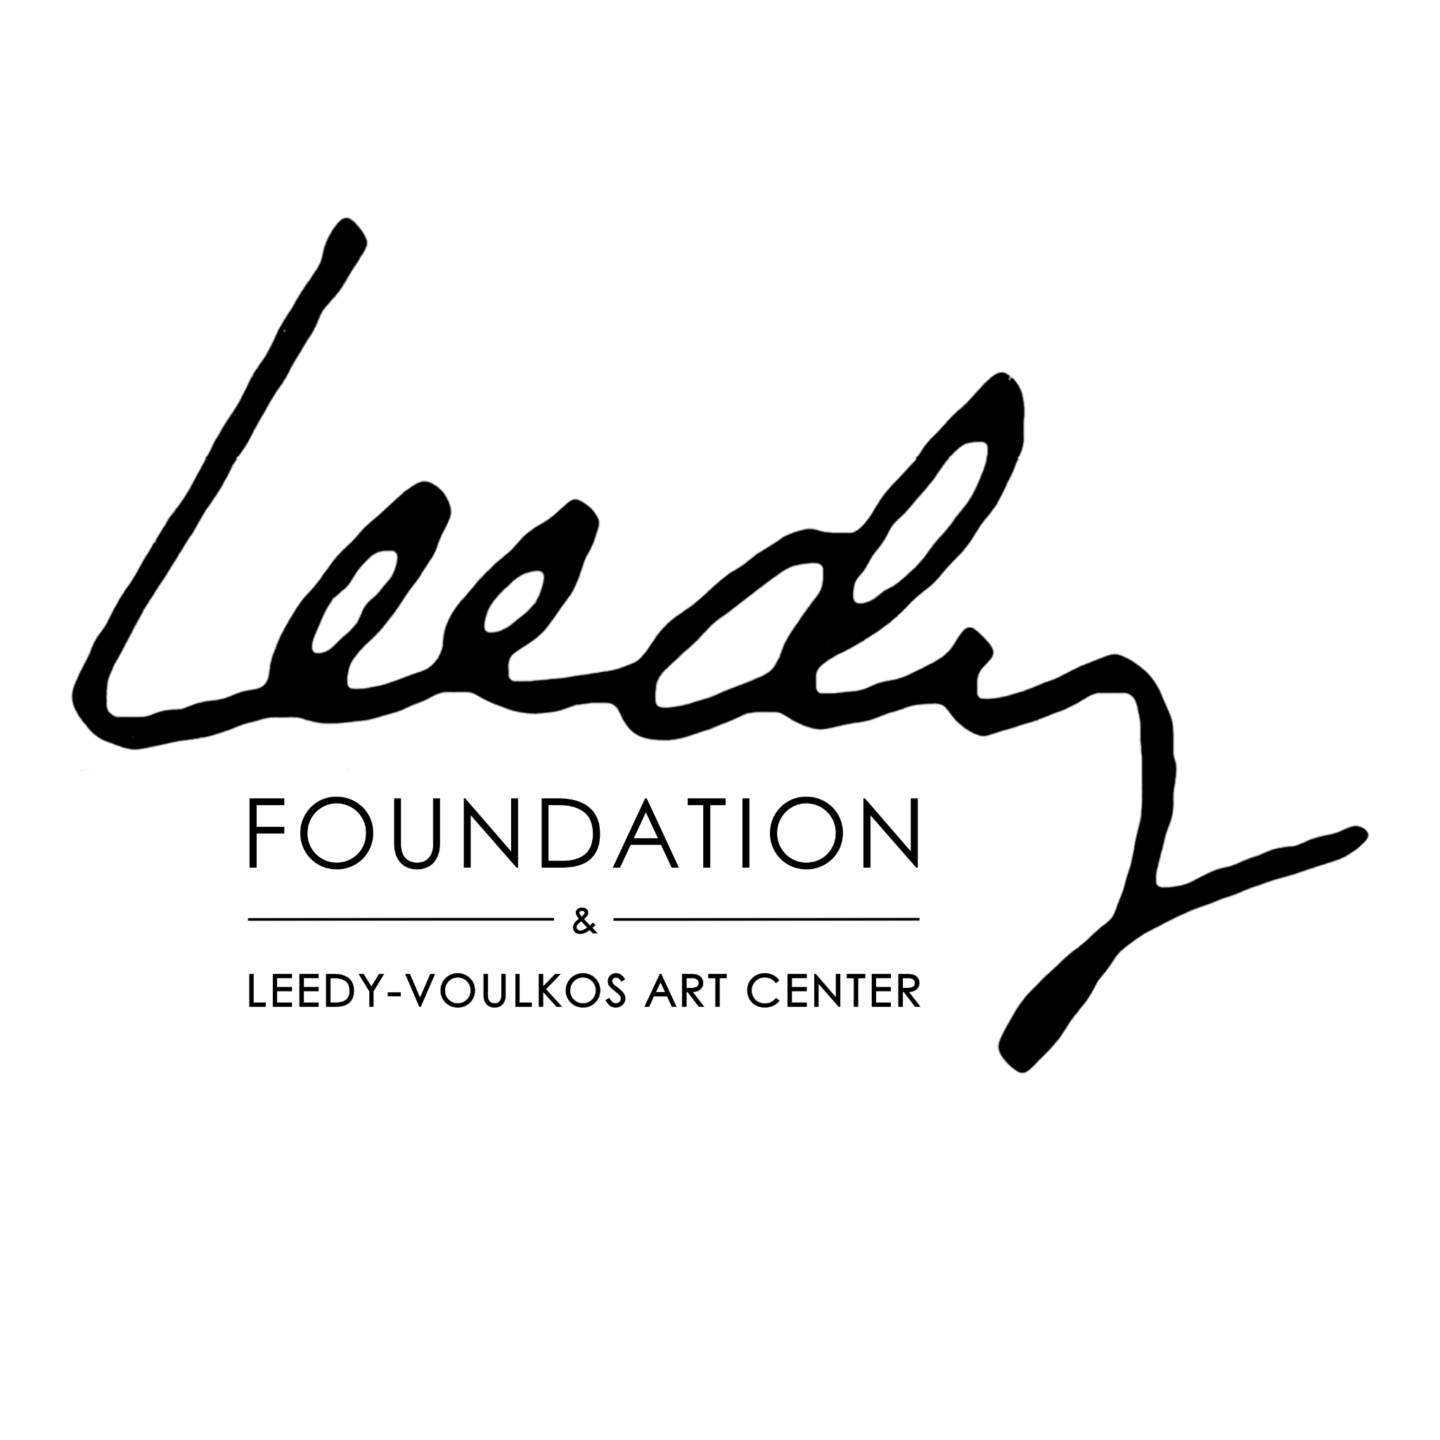

Leedy Foundation: How to Write Your Own Obituary: Reflection & Planning Worksheet
In Partnership with the Leedy Foundation
The Leedy Foundation preserves and celebrates artistic legacies through its archives, exhibitions, and programs. Including your connection to the Foundation can help situate your work within a broader community of artists and document your creative legacy for future audiences.
Writing your own obituary is not just a planning tool—it’s a way to reflect on your life, values, and artistic legacy. This exercise helps you live intentionally while preparing a meaningful record for the future.

Part 1: Reflective Insights
Writing your obituary can teach you how to live more purposefully. Consider these prompts before drafting:
- Clarity of Priorities: What truly matters to you in life and in your art?
- Focus on the Essential: Which achievements, experiences, or relationships bring the most meaning?
- Goal Setting & Direction: What ambitions or projects do you want to pursue intentionally?
- Personal Growth: In what areas of skill, character, or creativity do you want to improve?
- Relationships & Connections: Who are the people you most want to nurture and honor?
- Legacy & Contribution: How do you want your art and life to positively impact others?
- Leedy Foundation Connection: How does your work’s inclusion in archives, exhibitions, or programs reflect your legacy?
- Live in Alignment: How can your daily actions reflect your core values?
- Gratitude & Appreciation: What accomplishments, experiences, or people are you most grateful for?
- Mindfulness & Presence: How can you be more present and engaged in everyday life?
Tip: Answer these prompts in bullet points or short paragraphs. These reflections will feed directly into your obituary draft.

Part 2: Practical Obituary Planning
Use this section to structure the actual content of your obituary, focusing on your artistic life and contributions.

1. Personal Details
- Full Name (include professional/studio name if different):
- Birth Date & Place:
- Death Date & Place (if known):
- Surviving Family / Relationships:
- Preferred Name / Nickname:

2. Artistic Biography
- Mediums / Styles Worked In:
- Key Themes or Motifs:
- Education / Training:
- Major Career Milestones:
- Notable Collaborations / Partnerships:
- Awards / Honors / Recognitions:
- Influences & Inspirations:
- Leedy Foundation Participation: (Archive submissions, exhibitions, library inclusion)

3. Artistic Contributions
- Significant Works / Series (Title, Year, Medium, Location if public):
- Collections / Institutions Holding Work:
- Publications / Catalogues Featuring Work:
- Community Impact / Teaching / Mentorship:

4. Personal Voice
- Quotes or Life Philosophy:
- Personal Anecdotes Relating to Art Practice:
- Hobbies / Passions Outside Art (Optional):

5. Memorial & Funeral Details
- Type of Service (Funeral, Memorial, Celebration of Life):
- Date / Time / Location:
- Special Requests for Artwork Display:
- Music, Readings, or Speakers:
- Charities or Funds Suggested for Donations:

Part 3: Draft Space
Use this section to write a first draft of your obituary. Include reflections, achievements, Leedy Foundation contributions, and the aspects of your life and practice that matter most to you.

