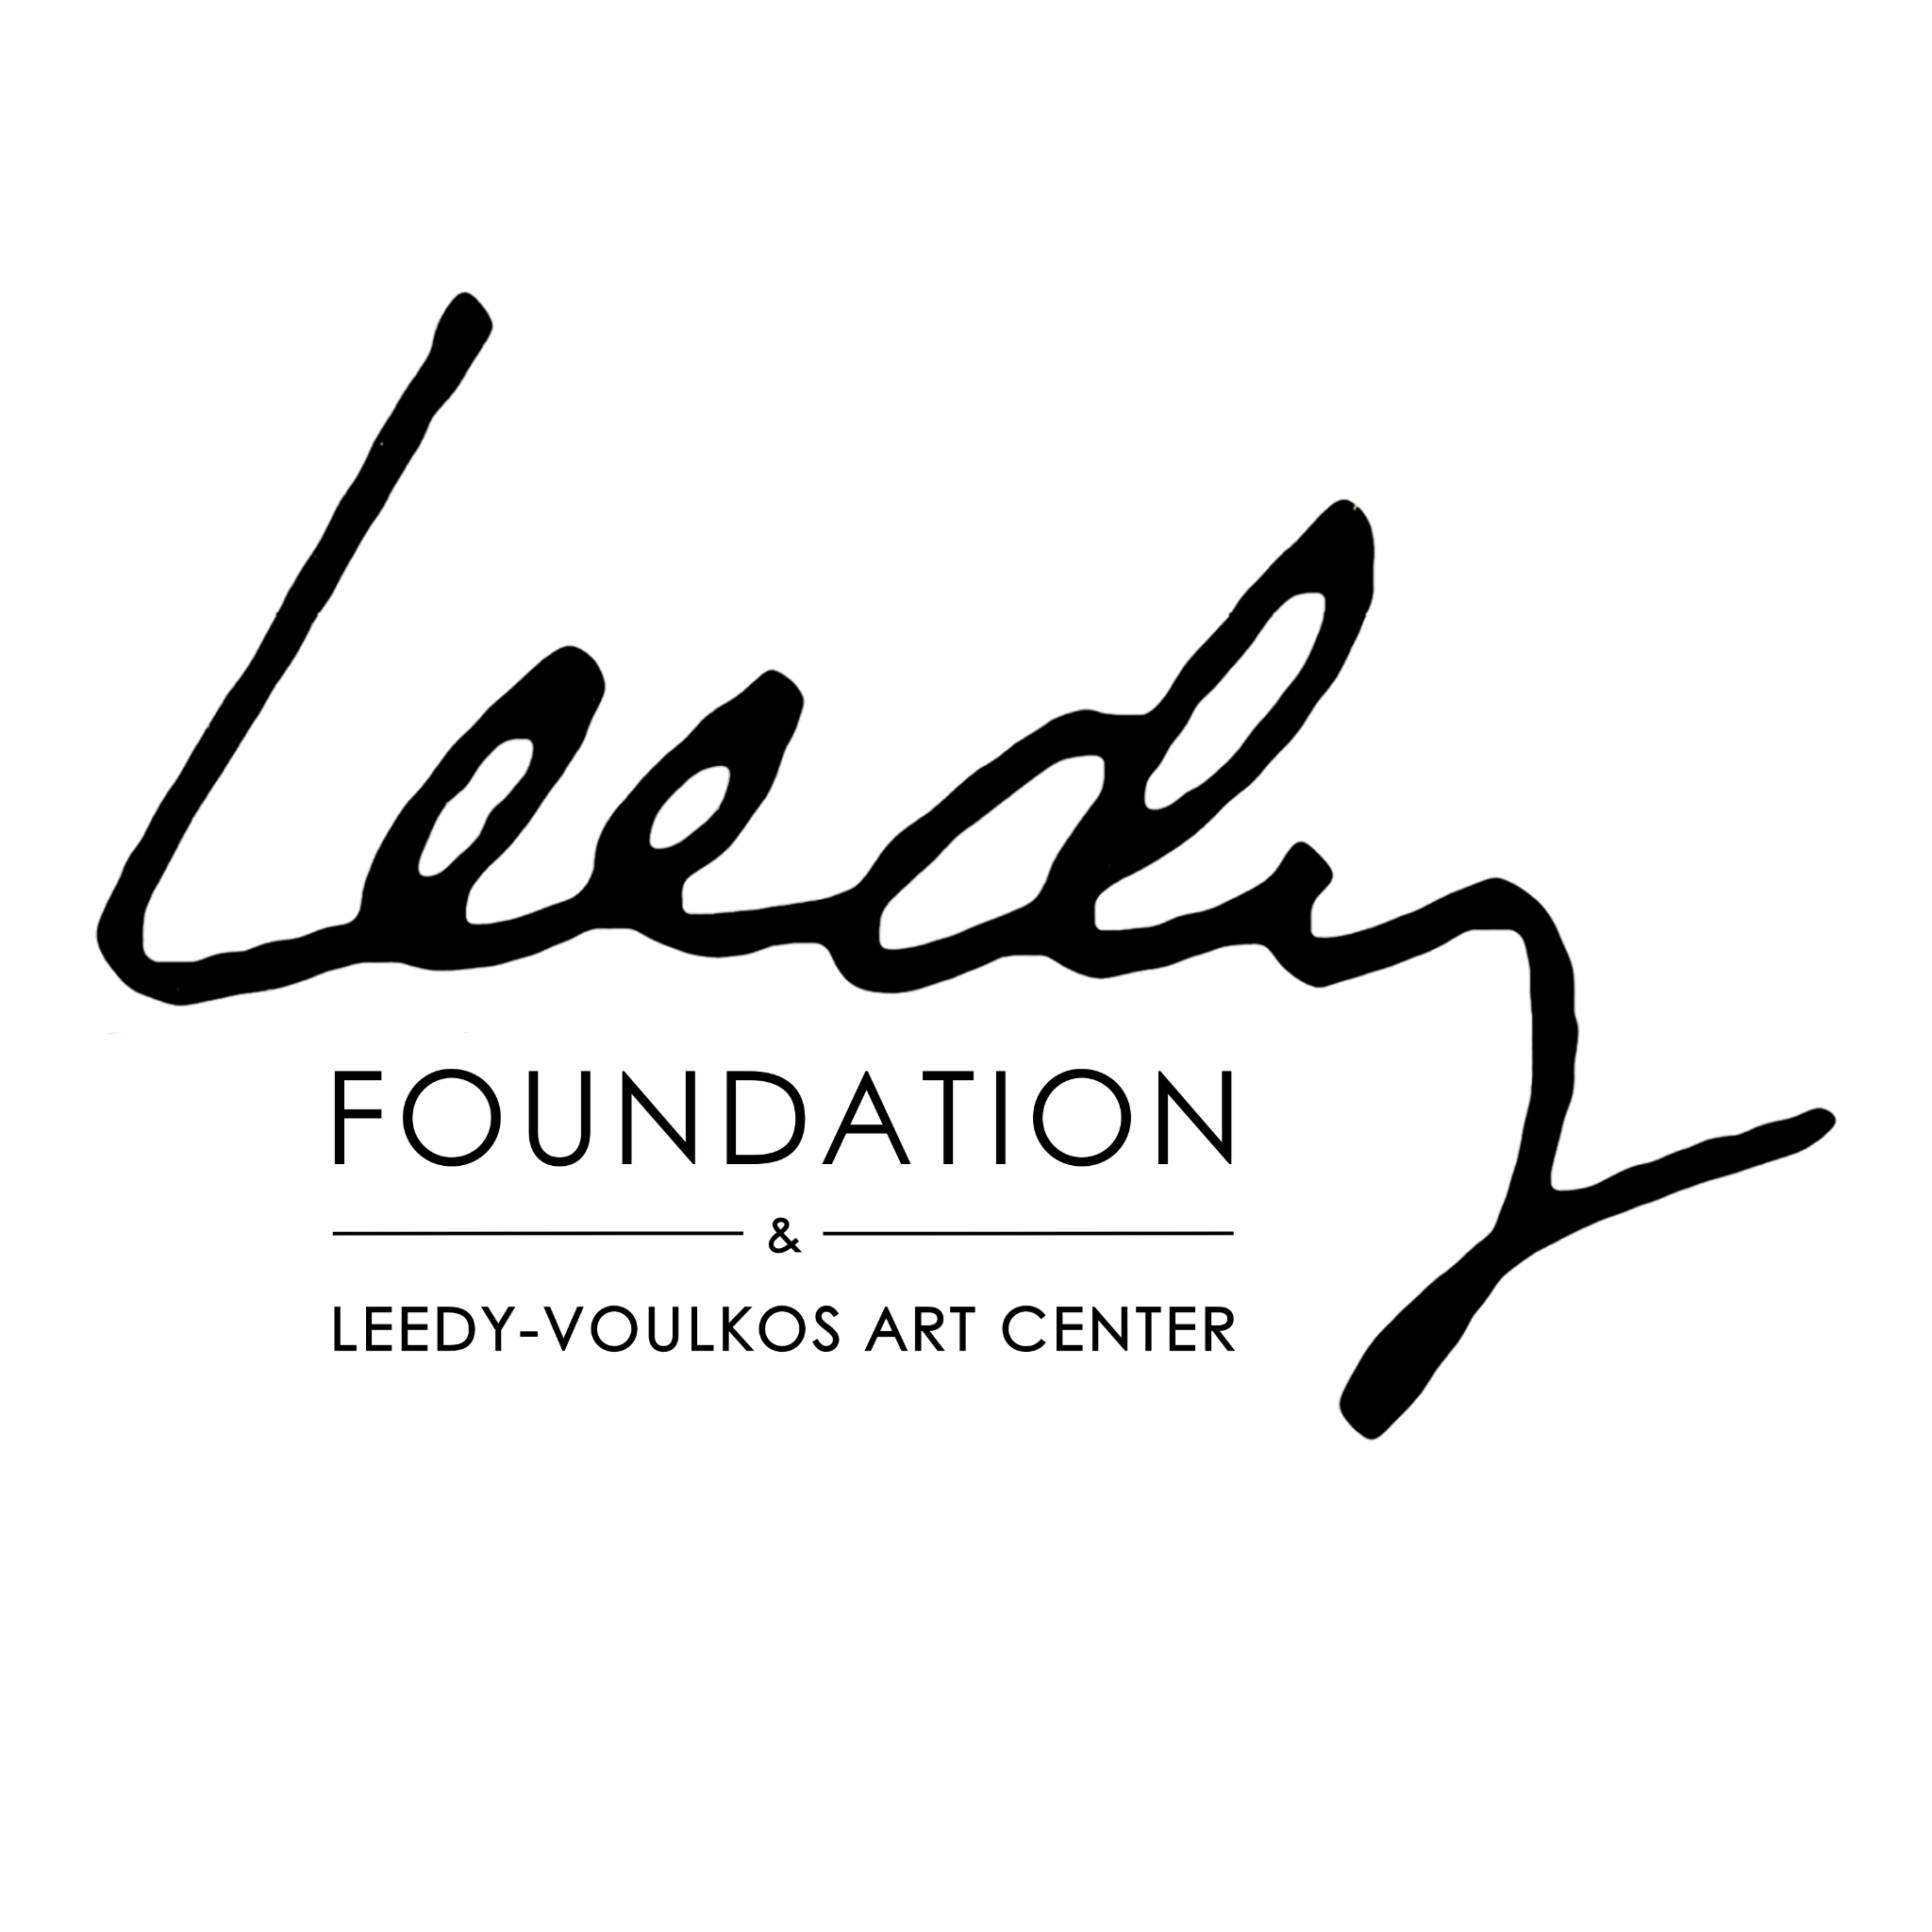

Leedy Foundation Artist Reflection & Legacy Worksheet: Writing Your Bio & Artist Statement
In Partnership with the Leedy Foundation:
The Leedy Foundation preserves and celebrates artistic legacies through its archives, exhibitions, and programs. Including your connection to the Foundation can help situate your work within a broader community of artists and document your creative legacy for future audiences.
This worksheet helps you reflect on the motivations, processes, and meanings behind your work, and use those insights to craft professional artist statements, bios, and legacy documentation. Complete sections in any order, using bullet points, sketches, or short notes.

Part 1: The Why – Motivations, Beliefs, and Intentions
- Why did you make this artwork?
- What do you believe in?
- What belief, idea, or concept are you investigating?
- How does your personal belief or viewpoint appear in your work?
- What emotion was primary while creating it?
- How does that emotion come through in the finished work?
- What were you thinking about during the process?
- What inspired this direction?
Notes / Responses:

Part 2: The How – Process & Approach
- How did you make this?
- How did you use or combine mediums?
- How did you physically engage in creation?
- How is it constructed?
- How are you uniquely presenting the subject?
- How did accidents or discoveries influence the work?
- How did you choose this medium or subject?
- How did exploration bring you to this work?
- How would you like viewers to approach it?
- How did you choose your palette?
- How does the form relate to the subject, and vice versa?
Notes / Responses:

Part 3: The What – Content & Meaning
- What is the viewer looking at?
- What is it made of?
- What was your process?
- What does it represent?
- What are you investigating or exploring?
- What are you combining or breaking apart?
- What inspired the direction of the work?
- What story does it tell?
- What did you learn while making it?
- What qualities or characteristics pervade the work?
- What keeps you curious, dedicated, or obsessed?
- What was involved in making it? (Collaboration, tools, research, multiple attempts)
Notes / Responses:

Part 4: Crafting Your Artist Bio & Statement
Use insights from Parts 1–3 to create your professional bio and statement.

Who Are You? (Biography Basics)
- Name:
- Place of origin / Current studio:
- Education / Training / Mentors:
- Professional Highlights (Exhibitions, Awards, Residencies):
- Mediums, Styles, or Specializations:
- Leedy Foundation Connections: (Exhibitions, archive submissions, library inclusion)

What Do You Do? (Art Practice)
- Key themes, concepts, or issues explored:
- Techniques, materials, and processes:
- Notable works or projects:
- Collaborations or community engagement:

How Do You Do It? (Artistic Process & Philosophy)
- How your approach or technique makes your work unique:
- How your beliefs, ideas, or values are expressed in your work:
- What you want the audience to understand, feel, or experience:
Tips:
- Bio: Third-person, concise, factual.
- Statement: First-person or third-person, reflective and descriptive.
- Highlight Leedy Foundation participation to demonstrate legacy and recognition.

Part 5: Draft Space
- Combine reflections from Parts 1–4 into full sentences for your artist bio, statement, or legacy documentation.
- Integrate the most compelling Why/What/How insights and your Leedy Foundation connection.

